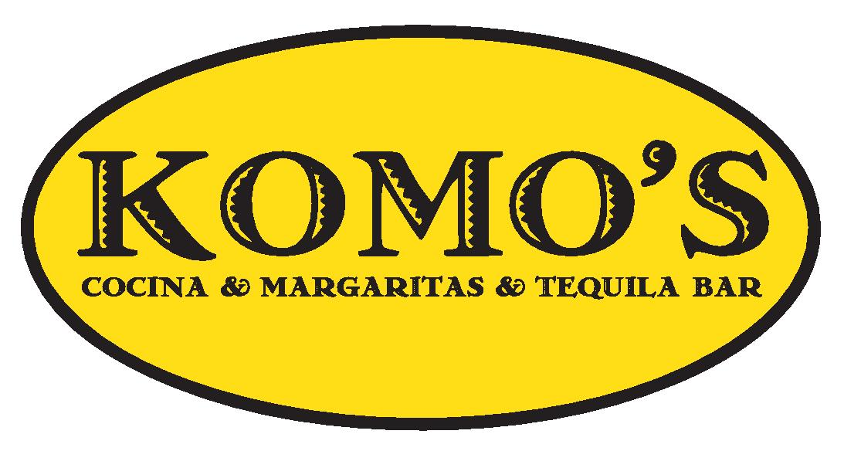
THREE COURSES | $35.00
Add a Famous Komo’s Margarita for just $5

CHOICE OF STARTER:
Shrimp Cocktail with our Homemade Cocktail Sauce
Or
Two Pork Belly Street Tacos
CHOICE OF ENTREE:
Blackened Salmon with served with Rice and Choice of Beans
OR
6-Ounce Flat Iron Steak with Bleu Cheese Cream Sauce, Served with Mashed Potatoes and Sauteed Vegetables
CHOICE OF DESSERTS
