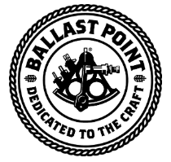

DINE OUT LONG BEACH

SPECIALS

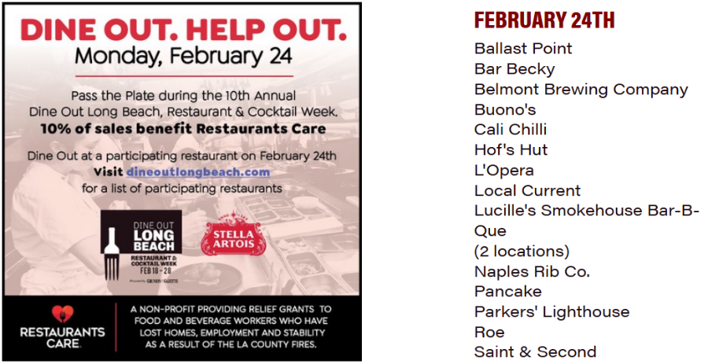

**Mains**

***Enjoy each meal with an expertly paired beer.***

**Lobster Arancini** 18

Locally harvested lobster, stuffed in a crispy fried risotto ball, filled with fresh mozzarella, served with a side of warm zesty jalapeno corn tip.

*Paired with ______ 8oz*

**Fried Caprese Salad** 16

Locally made Distefano Burrata, coated in a fine Italian herb seasoned breadcrumb, locally harvested heirloom tomatoes, drizzled with California grown olive oil, sweet and tangy apricot mostarda.

*Paired with ______8oz*

**Spaghetti al “Cali”** 24

California inspired spaghetti, featuring locally sourced shrimp, creamy avocado pesto, heirloom cherry tomato, crunchy California almonds, with peppery rocket arugula.

*Paired with ______ 8oz*

**Grilled Swordfish** 30

Fire grilled swordfish, spicy chorizo potato salad, sauteed broccolini, charred lemon.

*Paired with ______ 8oz*

**Dessert**

**Butter Pecan Brownie Sundae** 14

Warm fudge brownie, topped with locally made pecan butter ice cream, drizzle of chocolate and caramel sauce, and whipped cream.

*Paired with ______ 8oz*